Geopolitics: Phase I
Name of Student
Institutional Affiliation

Geopolitics: Phase I
- How Geopolitics Has Empowered Brazil In Terms Of International Trade
Introduction
Over the years, Brazil has had largest economy in South America and its democracy has been firm since its inception. Due the vast growth in economy, Brazil is placed in the category of BRICS countries, an economic block formed by member countries like India, Russia, South Africa, and even Brazil. The capital city of Brazil is called Brasilia while the largest city in Brazil is called Sao Paulo. According to the 2012 UN estimations, Brazil had a population close to 199.5 million people and the life expectancy for both men and women is 71 years and 77 years respectively. The main exports of Brazil are coffee beans, iron ore, oranges among other agricultural produce. Brazil as a country has made a lot more effort to raise millions of its population out from shortages in terms of food and other amenities. This paper will discuss how geopolitics has impacted international trade in Brazil. The paper will also discuss how technology has changed the way we view geopolitics.
Demographic study carried out by Ferretti (2018) suggested that hosting both Rio Olympics and FIFA World Cup in 2014 changed the economy of Brazil for better. The economy of Brazil has changed from 3.6 to 5.0 billion US dollars indicating that Brazil as a country will get out of poverty in the subsequent years. Geopolitics has played a pivotal role in the boosting of Brazil economy both locally and internationally. This has attracted many Business investors who are helping the country to grow even more and gain favourable competition in the international market (Ferretti, 2018). Brazil is regarded as a nation of developing opportunities, and the government and leaders have struggled to do away with corruption and lowered taxes to promote local and global trade. Geopolitics has also empowered Brazil to develop in terms of imports and exports and in developing new technologies, as well as the necessary infrastructure.
The GDP of Brazil
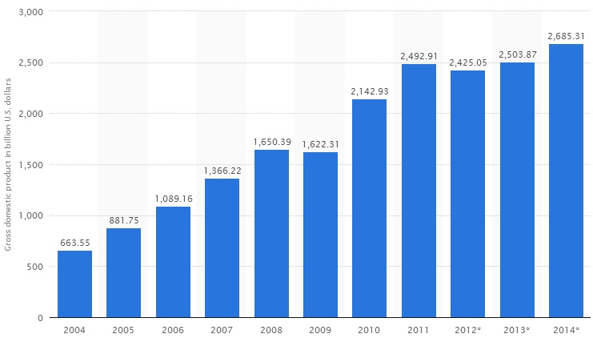
(Vyas & Kumaranayake, 2006)
The above statistics displays GDP of Brazil for a period of ten years from 2004 to 2014. This statistics indicates that the economy of Brazil increased significantly for the specified period of ten years from an amount of 0.6 trillion US dollars in 2004 to an amount about 2. 86 trillion US dollars recorded in 2014 respectively.

Trend of Brazilian GDP 2004-2014
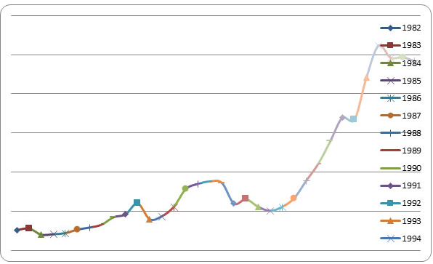
(Schlemper, Stewart, Shetty & Czajkowski, 2018)
Brazil’s GDP Per Capita Income
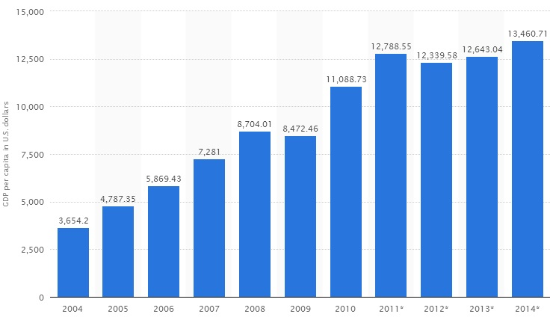
(Ferretti, 2018).
The statistics in the above chart indicates Brazil’s Gross Domestic Product per capita for a duration of ten years (2004-2014). This statistic clearly indicates that Brazil’s Per Capita Income of raised to 9.8 trillion US dollars in the specified period of ten years, which is 2004 to 2014.
GDP Growth Rate of Brazil 2004-2014
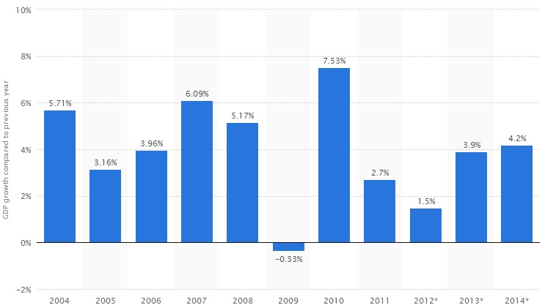
(Reyes, 2018).
The above statistics displays Gross Domestic Product (GDP) growth rate of Brazil for the specified period of time which is 2004 to 2014. The economy of Brazil based on the above statistics decreased significantly between 2011 and 2012. The statistics also shows the growth rate of 7.54% in terms of Gross Domestic Product in 2010 which decreased to 2.8% in 2011 and further and in 2012 reduced to 1.6%. The GDP of Brazil in 2012 was 2.43 trillion United States dollars, this placed Brazil in position seven among the wealthiest economies in the world (Reyes, 2018). The enormous economy also puts Brazil in a position of being the largest country that has a large population and a vast area in square kilometers in both Caribbean and Latin America. However, the retarded growth rate in the period between 2011 and 2012 contributed by both external and domestic factors seriously bared potential business men and women from investing in Brazil. The industry output was also disproportionately affected by the sow growth rate between the periods mentioned above.
What makes Brazil to be less susceptible to external economic crisis is their strong domestic market. The population of Brazil can therefore, continue to benefit from the country’s stable economic growth as the financial sector in this country always strives to weather the slowdown in economy (Cohen, 2018). The 2014 FIFA World Cup was held in Brazil and this encouraged enormous investments in various sectors and other forms of infrastructure. The massive investments in different sectors made the Brazil’s Gross Domestic Product to shot to 2.69 trillion United States dollars in 2014.
According to the International Monetary Fund (IMF), international trade in Brazil has increased by about 5.2%, given that the country has fortified their geopolitics. Brazil is the seventh largest economy in the world (Ferretti, 2018). In 1990 real plan advent and hyper- inflation the country’s poverty has dropped. The government has a heavy intervention the economy of the country which limits the development of the nation. The government favour most domestic goods and controls the use of imports like cars and clothing. In the fifth quarter this January the economy has gone down by 0.3%. The economists predicted the fall would be 0.8%, however it wasn’t that bad. The removal of the President Dilma Rousseff caused a political and economic crisis.
The economy of Brazil has tremendous improvement between the year 2003 and 2014. Around 29 million people have come out of poverty in this period. The income level of the low income people rocketed reducing the gap earning gap to an extent. The country is undergoing a deep recession. The GBP has shrunk by 3.8% in the year 2015 (Cohen, 2018). The crisis is further exacerbated when the commodity prices dropped. The regularization and the pass through in the exchange rate caused the inflation rate to shoot up to an all-time high. The government is taking several measures to keep the situation in control and reduce the inflation. Macro-economic adjustments and plans has been initiated.
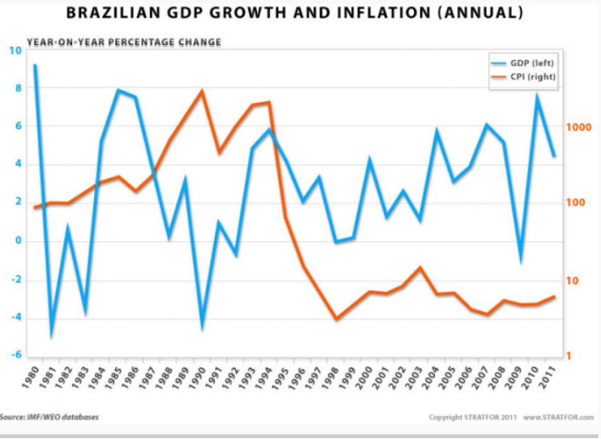(Reyes, 2018).
The change in the policy to boost the economy include many reforms like increasing the competitiveness, investment and productivity. There is also extreme difference in among the regions of the country. The south and the south east parts of the country have high potential for development rather than the North and North east (Vyas & Kumaranayake, 2016). Brazil’s medium term growth depends on this adjustment made. For the growth to be higher they need more investments in the country. At present the country’s population is 204 million (2015). The GDP per capita is 8651 USD and inflation is at 11.3%. The economy of the country is continuously shrinking. According to 2016 Economic freedom score Brazil’s score is 56.5 which is 0.1 point less than the previous year. Brazil ranks 122nd place on the Global ranking. When considering the Central American and Caribbean region the country ranks 21st place. The private sector domination and increase in public debt are the major reason for the economic pressure.
- How Advancement in Technology Affected Geography’s Importance in Geopolitics
Advancement of technology has helped in the restoration of many geopolitical spheres on the globe for instance in the field of research. In any case, the research helps in finding issues in relation to the progress of the Bitcoin on the international market and more importantly the impact the globe as a whole has had so far since the induction in 2009. The study plays a pivotal role in ensuring that all factors required for Bitcoin stability and the large block chain business are exploited to the knowledge of investors and interested parties. It also expounds knowledge of the Bitcoin business that is taking place all over the globe. The issue on Bitcoins and digital currency has come into place courtesy of technological advancement.
Advancement in technology has led to the development and use of Bitcoins in the nation and across the globe. Bitcoins could replace the US dollar in the opinion put forward by the Coin base Cofounder and other analysts in the currency world. The renowned currency analysts predict the ability of the created digital currency taking over the position held by the US dollar as a global currency reserve in the years to come if and only if bitcoins get past the many obstacles that lie ahead (Focacci, 2017). It is to the knowledge of the currency reservist and all parties entailed to get to the bottom line of the matter and ensure that the many milestones that lie ahead of the bitcoins journey to becoming the world reserve currency.
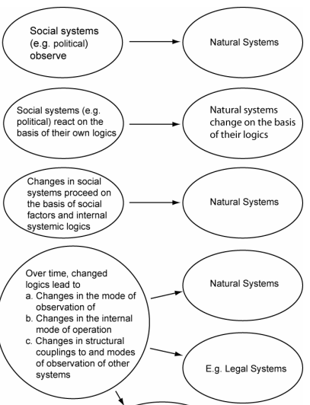
(Ferretti, 2018).
Technology has led to a robust growth of Brazilian GDP by a significantly huge percentage. Technology has contributed immensely to the growth of many sectors across the nation for instance those that deal in telecommunication as well as technology related services. Taking the case of growth in national GDP for cases of nations like for instance Brazil that have had an improved economy for years due to technological advancement. Talking of the progress that most nations have made so far in the 21st century as well as a clear analysis of the nations’ progress in the economic arena, one would not doubt the greatness that is anticipated for the nations due to technological advancement. An overview of steps made in the last three decades more specifically in the military service provides hope to the nation of the number one superpower category that would likely happen in the coming few years.
Brazil is more likely to increase in terms of revenue growth for the national development as well as for global competition. In terms of geographical development the nation would make huge steps in the development of artificial and natural resources to match those of the bigger economies given that the nation embrace technological development. It is a matter of time that the nation would experience an enormous technological impact in almost all sectors of the economy upon embracing technology as a whole.
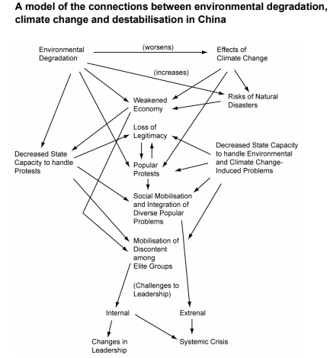
(Cohen, 2018).
Technology advancement has allowed substantive growth in the nation. It is the fasted growing service in the entire nation both globally and locally. The fact that there have been growth also links the process to some setbacks. The points of strength that have led to the growth are the ever increasing demand from customers in search of the services as well the willingness of the government to support the business (Focacci, 2017). The governments across the world have shown interest in the growth of telecommunication in a way that it subsidizes the business since telecommunication as a whole breeds market for other industries in the nations. The government support for the industry has been in the limelight across the globe as most of investors both local and international have been given support to venture into the telecommunication business. The nations in South America in as much as they rely on other means of economic development wholly making them to feature as the average nations across the globe in a way have embraced telecommunication. Brazil for instance have had an increase in GDP per capita courtesy of the nation’s willingness to engage in economic development.
The nation has shifted from wholly relying on oil to other business portfolios all in the name of diversification. The effort that is echoed in most of the South American nations as per the 2018 fiscal year summit aims at ensuring an increase in the job opportunities in the nations for the people as well as improvement of social amenities. Brazil is expected to make a move in the boosting of geopolitical influence in region upon the construction of land routes estimated for $54 billion all the way from city to water port Argentina. Pinning down to Brazil as a good example of nations that have experienced technological advancement, one can easily express their findings on the nature of business that technology as a whole has brought into force. Embracing technology goes a long way in as far touching on the nation’s borders and the defence system of the country all through use of modern weaponry that utilize technology hence making the nation bid against her enemies.

References
Ferretti, F. (2018). Geographies of internationalism: Radical development and critical geopolitics from the Northeast of Brazil. Political Geography, 63, 10-19. Retrieved from https://www.sciencedirect.com/science/article/pii/S0962629817302597
Reyes, C. V. (2018). Energy Integration in South America and Global Geopolitics. In Regionalism, Development and the Post-Commodities Boom in South America (pp. 147-164). Palgrave Macmillan, Cham. Retrieved from https://worldview.stratfor.com/article/geopolitics-brazil-emergent-powers-struggle-geography
Schlemper, M. B., Stewart, V. C., Shetty, S., & Czajkowski, K. (2018). Including Students’ Geographies in Geography Education: Spatial Narratives, Citizen Mapping, and Social Justice. Theory & Research in Social Education, 46(4), 603-641. Retrieved from https://www.geopoliticalmonitor.com/how-oil-and-primary-exports-impact-brazils-economic-fortunes/
Cohen, S. B. (2018). Geopolitics in the new world era: a new perspective on an old discipline. In reordering the world (pp. 40-68). Routledge. Retrieved from https://www.taylorfrancis.com/books/e/9780429494741/chapters/10.4324/9780429494741-3
Focacci, A. (2017). Empirical analysis of the relationship between total consumption-GDP ratio and per capita income for different metals: The cases of Brazil, China and India. International Journal of Social Economics, 34(9), 612-636. Retrieved from https://www.academia.edu/3354871/Introduction_to_geopolitics
Vyas, S., & Kumaranayake, L. (2016). Constructing socio-economic status indices: how to use principal components analysis. Health policy and planning, 21(6), 459-468. Retrieved from https://www.heritage.org/index/country/brazil

